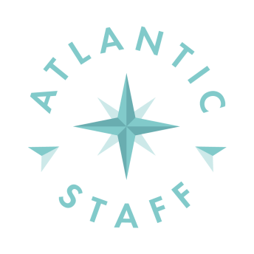 | Russia, Kaliningrad  General – Lieutenanta Ozerova street 17-b. of.706  +74012522131  +37065573 603  info@atlanticcrewing.com  www.atlanticcrewing.com | foto

Position

Surname | First name | Middle name

Permanent address | E-mail

Date of birth | Place of birth | Citizen | Min.salary

Mobile | Home phone | Nearest Airport

Marital status  ☐ Married ☐ Single ☐ Divorced |  | Childrens (numbers / age)
Next of kin (name/relation)
Next of kin (address) |  |  |  | Next of kin (phone)
Height (cm) | Weight (kg) | Overall size |  |  | Shoes size
Knowledge  ☐Fluent ☐ Good ☐ Satisfactory ☐ Poor |  |  | Other languages

Manager comments:

Licenses&Certificates | Document Number | Date of expiry | Place of issue
Certificate off competency
Seamans passport
Travel passport
Basic safety
Craft&Boats
Fire fighthing
Medical first
GMDSS
RADAR
APRA
Oil/Chemical
Ship sec. Officer (ISPS)
Ship security (section A-VI/6-2)
US VISA
Schengen VISA

Graduated from |  | Date
Yellow fever (date of vaccination) | Last medical examination

Details of previous sea service

Rank | Name of ship power | Flag | Name of vessel | Type of vessel | Type of engine | DWT | From | To

Date | Signature

